- List 3 real-world devices in your home or college that use SMPS (Switched Mode Power Supply) and 2 devices that use UPS (Uninterruptible Power Supply), explaining in one line why each device needs that type of power supply.
ANS:
SMPS Devices
- Desktop Computer – Converts AC to stable DC power.
- Laptop Charger – Supplies the correct DC voltage.
- LED TV – Provides efficient and regulated power.
UPS Devices
- Desktop Computer – Prevents data loss during power cuts.
- Wi-Fi Router – Keeps the internet running during outages.

- Draw and label a diagram showing the main internal components of a typical SMPS unit found in a desktop PC, including AC input, rectifier, transformer, and DC output sections.<br><br><em><strong>Hint:</strong> You can hand-draw and upload a photo, or use any free diagram tool like draw.io.</em>

Ans: 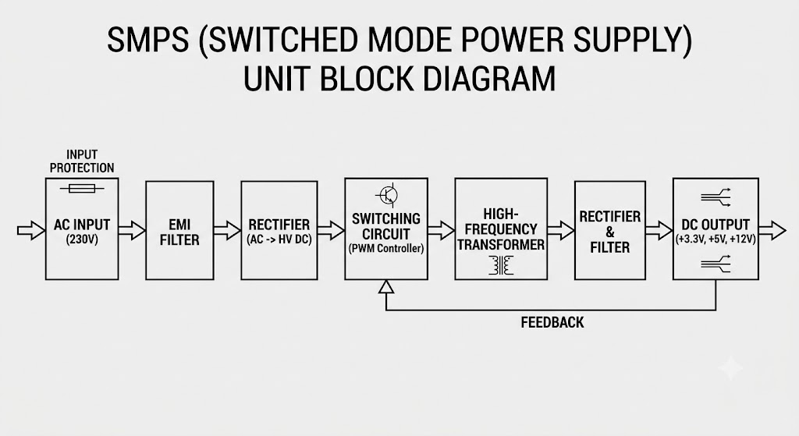
- take photos or find clear images online of the following power connectors: ATX 24-pin motherboard connector, SATA power connector, Molex connector, and PCIe 6/8-pin connector. For each, write its name, the devices it powers, and one safety tip for connecting/disconnecting it.
Ans:
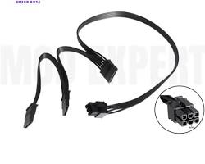
- Imagine you are setting up a new gaming PC. List the steps you would follow to connect the SMPS to the motherboard, graphics card, and storage devices, mentioning which specific cables and connectors are used for each.
Ans:
Steps to Connect the SMPS in a Gaming PC
- Connect the Motherboard
  - Cable/Connector: 24-pin ATX power connector.
  - Plug it into the motherboard's 24-pin power socket.
- Connect the CPU
  - Cable/Connector: 8-pin (4+4) EPS CPU power connector.
  - Connect it to the CPU power socket near the processor.
- Connect the Graphics Card (GPU)
  - Cable/Connector: PCIe 6-pin or 8-pin power connector.
  - Plug it into the graphics card power connector.
- Connect Storage Devices
  - Cable/Connector: SATA Power connector.
  - Connect it to the HDD, SSD, or SATA DVD drive.
- Check All Connections
  - Ensure every connector is firmly inserted before turning on the PC.

